WEEK 8-Multithreading and Muli processing

- A weather station sends temperature readings to an analysis unit. Write a Python program in which one process sends a list of temperatures to another process through a pipe. The receiving process calculates the minimum, maximum, and average temperatures and returns the results for display.
Sample result
Temperatures: [28, 30, 32, 29, 31]
Minimum: 28
Maximum: 32
Average: 30.00

- A restaurant receives orders containing an order ID, dish name, quantity, and unit price. Write a Python program in which one thread adds orders to a queue and three chef threads process them. Ensure that each order is processed exactly once. Safely update the total sales, display the chef handling each order, and terminate all threads after processing finishes.
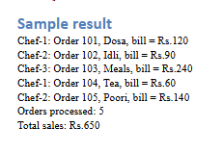
- A warehouse maintains stock for several products. Supplier threads add stock while customer threads purchase products simultaneously. Write a Python program to synchronize stock updates, reject purchases when stock is insufficient, and maintain a transaction record. Display the final stock and the number of successful and rejected purchases after all threads finish. (use locks)
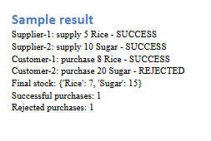
- A theatre has 20 seats, and multiple customers attempt to book tickets simultaneously. Each customer requests a specified number of seats. Write a Python program using threads to prevent overbooking and assign unique seat numbers to successful bookings. Display each customer’s booking status, allocated seats, and the final number of available seats.(Shared Memory)
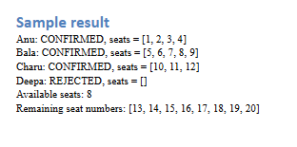
- A supermarket has three billing counters serving customers from a common queue. Each customer record contains a customer ID and a list of item prices. Write a Python program using three processes to calculate bills and send completed bills to the main process through a results queue. Ensure that every customer is served exactly once and display the total revenue after all processes finish.
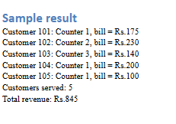
- Several family members access a shared bank account with an initial balance of ₹10,000. Write a Python program using separate processes to perform deposits and withdrawals. Store the balance in shared memory and synchronize updates using a lock. Reject withdrawals when funds are insufficient, send transaction outcomes to the main process, and display the final balance and transaction summary.
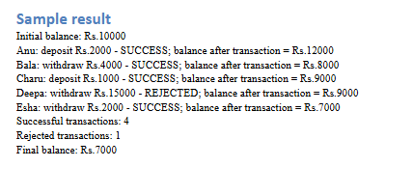
- A college maintains student marks for several departments. Each student record contains a roll number and marks in three subjects. Write a Python program using a process pool to analyse departments concurrently. Calculate each student’s total and average, identify the department topper, and count students who passed all subjects, using 40 as the pass mark in each subject. Display a consolidated report .
